Q1)



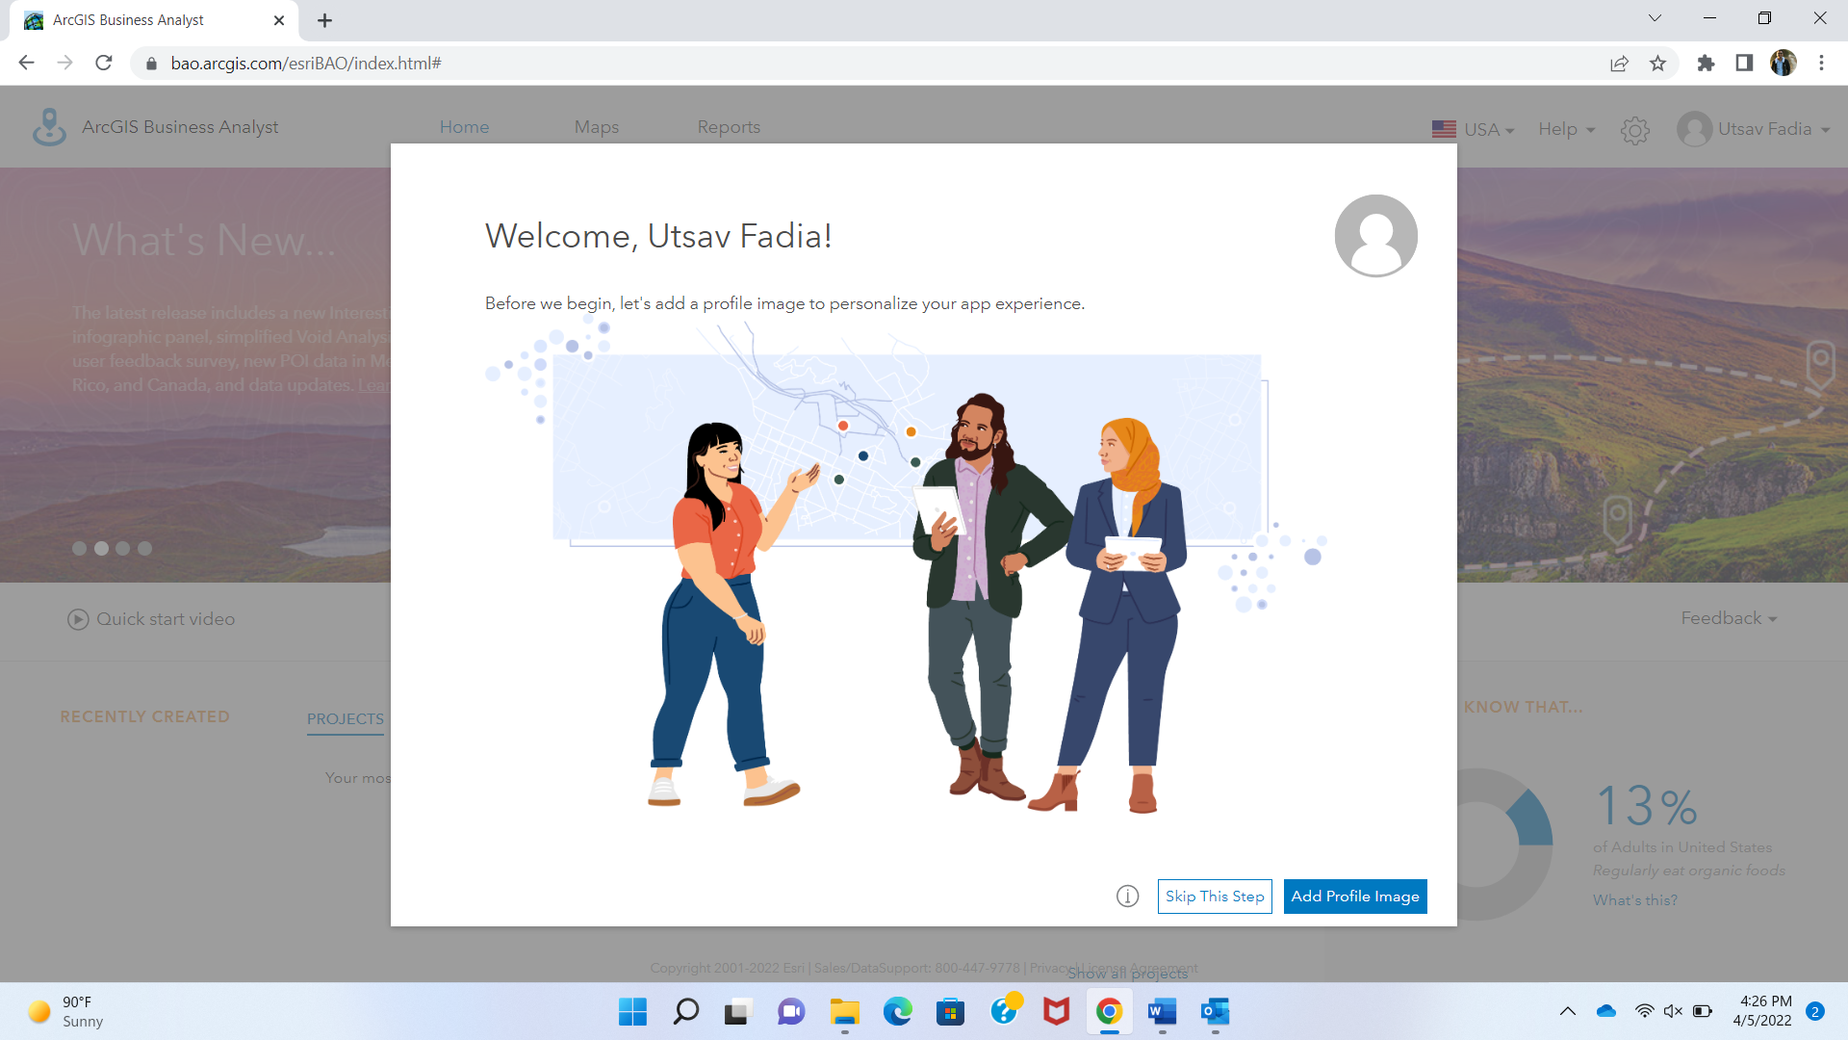

Q2)

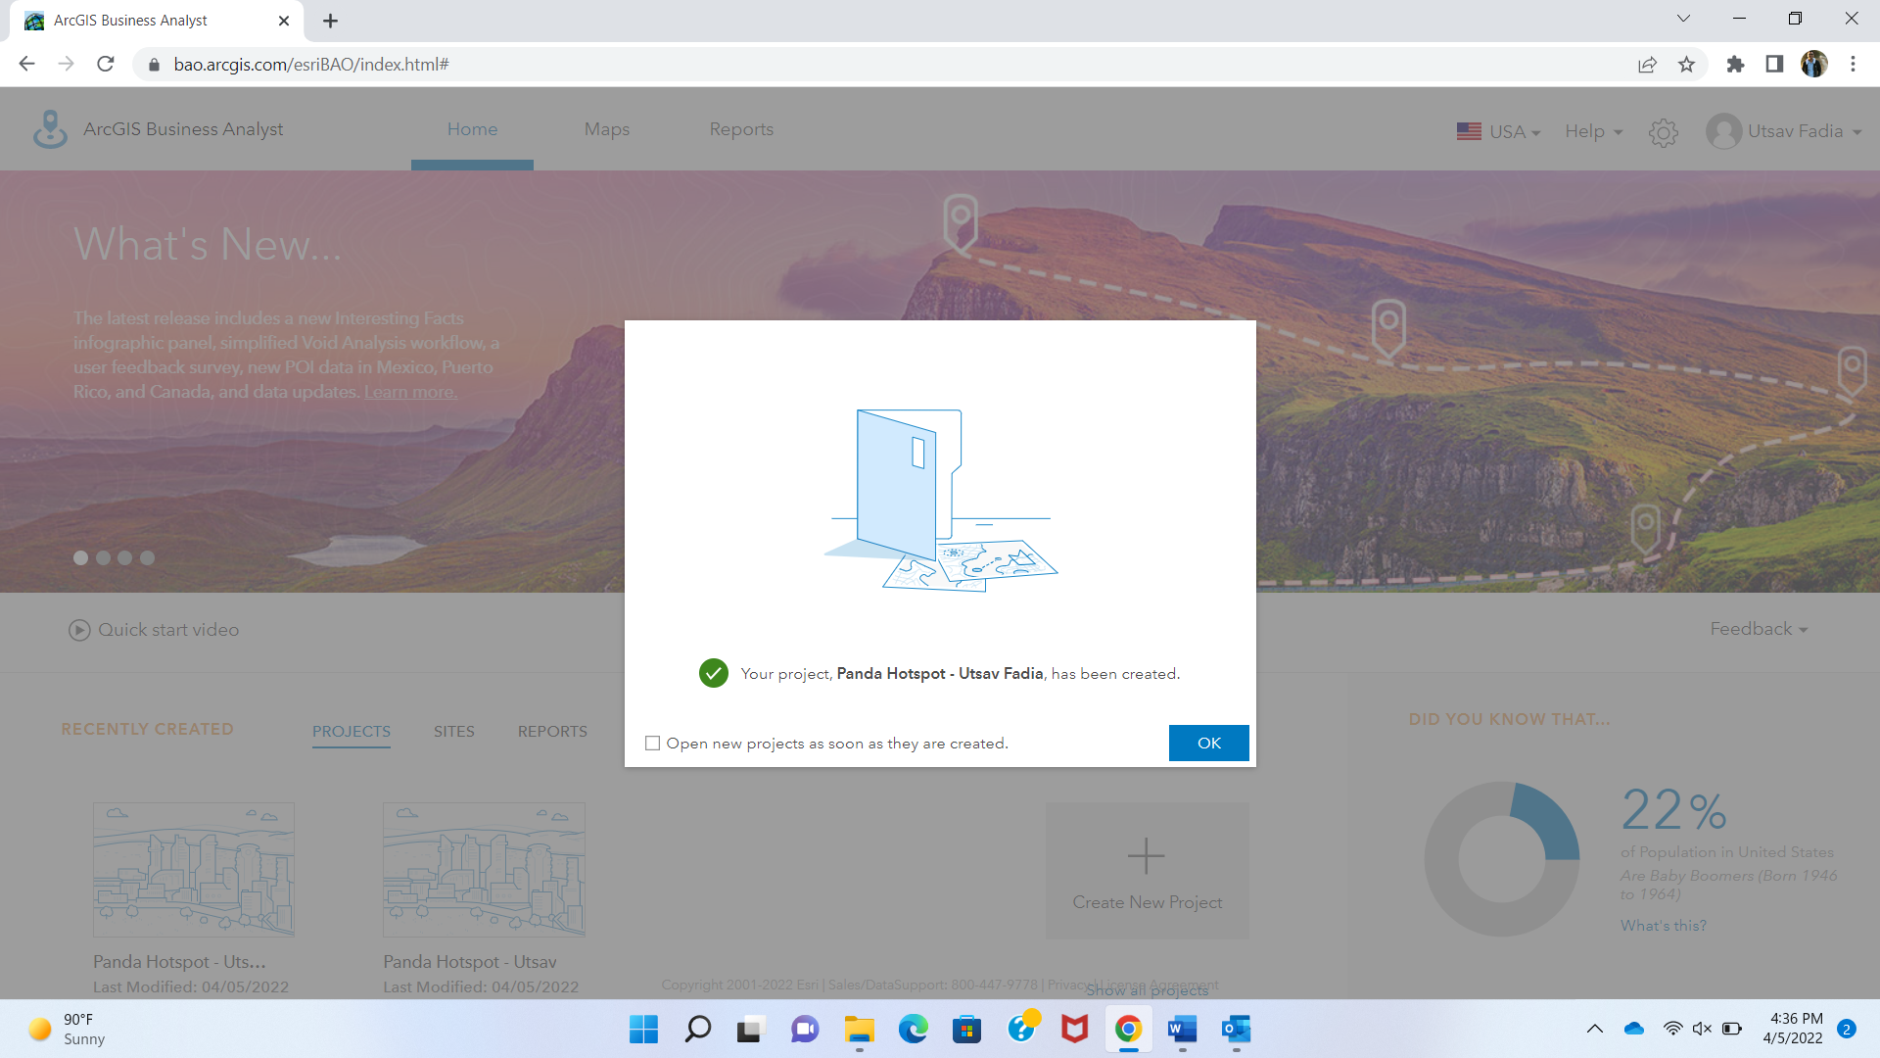

Q3)

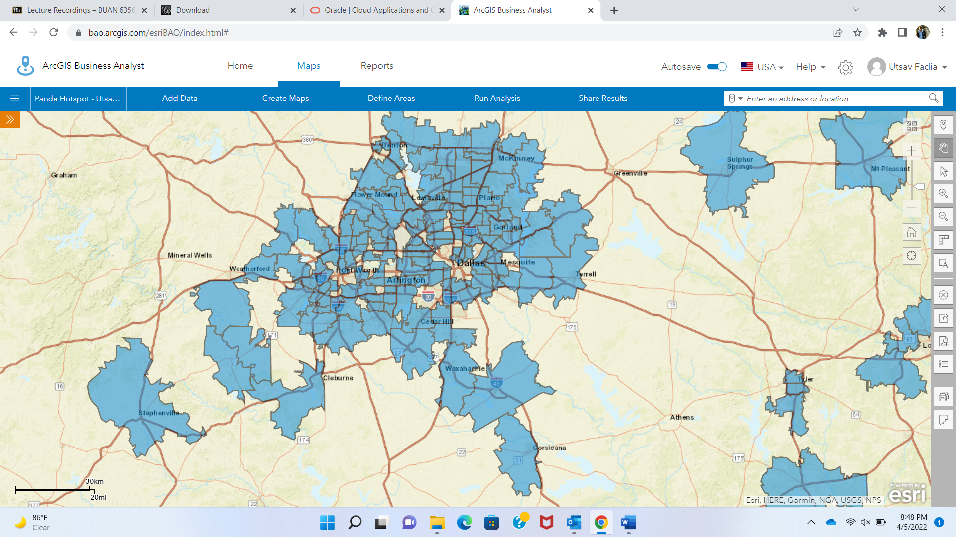

Q4)

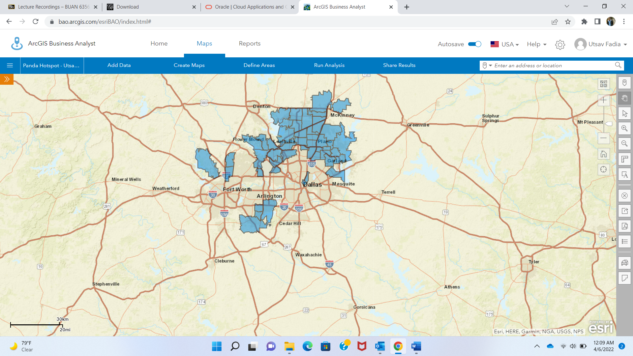

Q5)

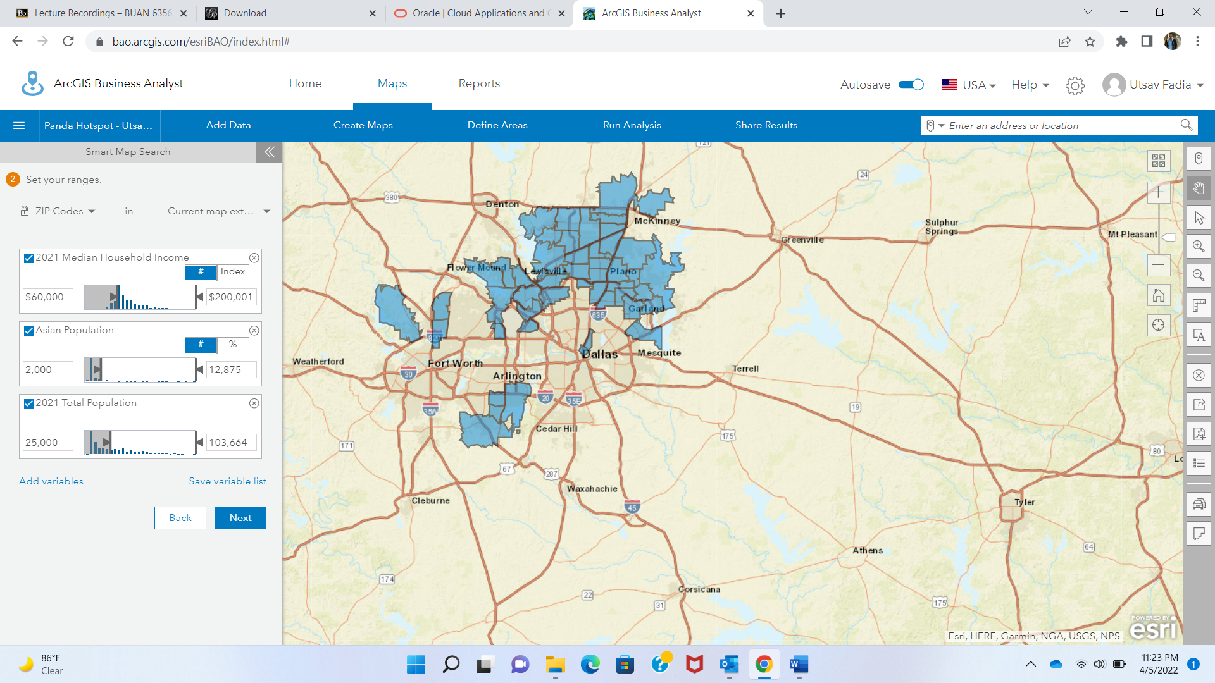

Q6)

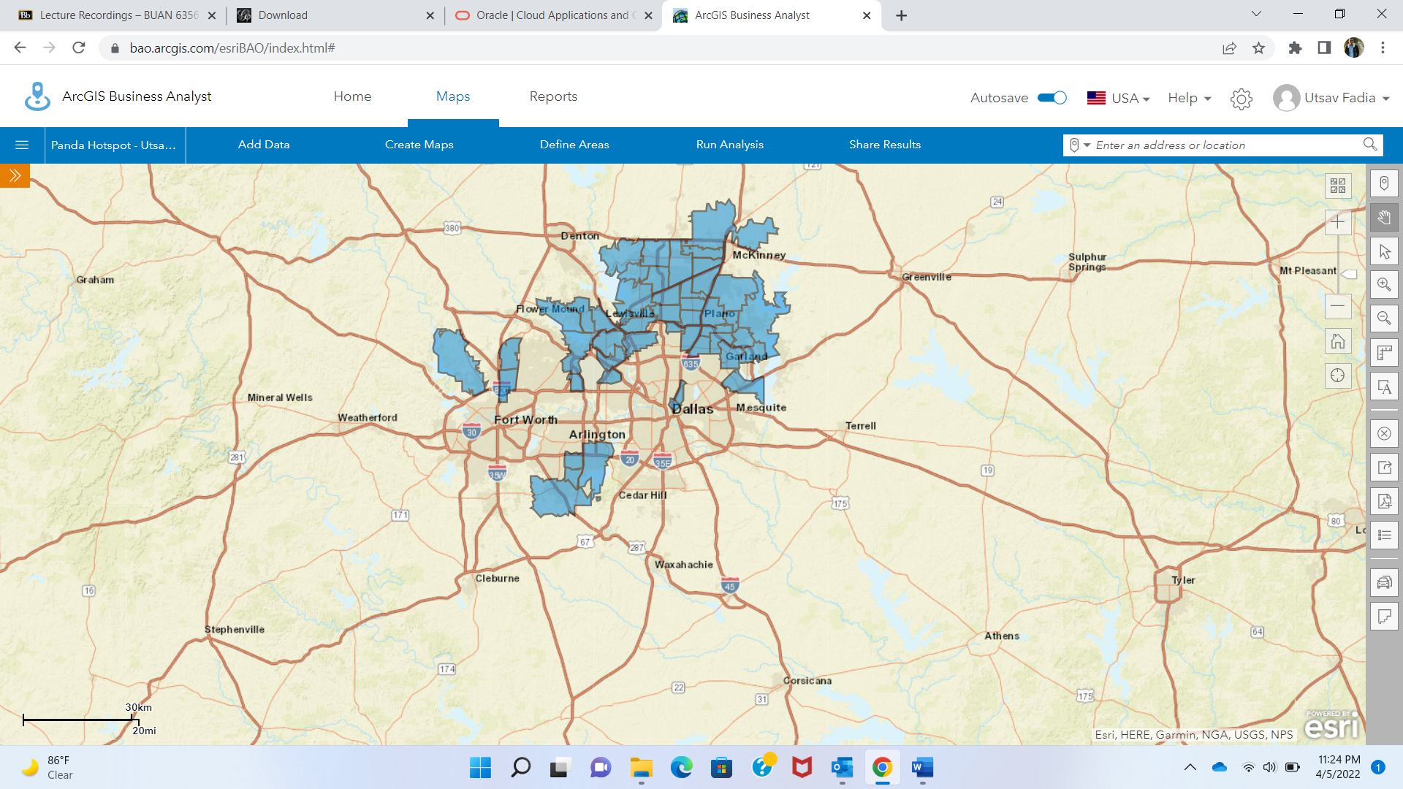

Q7)

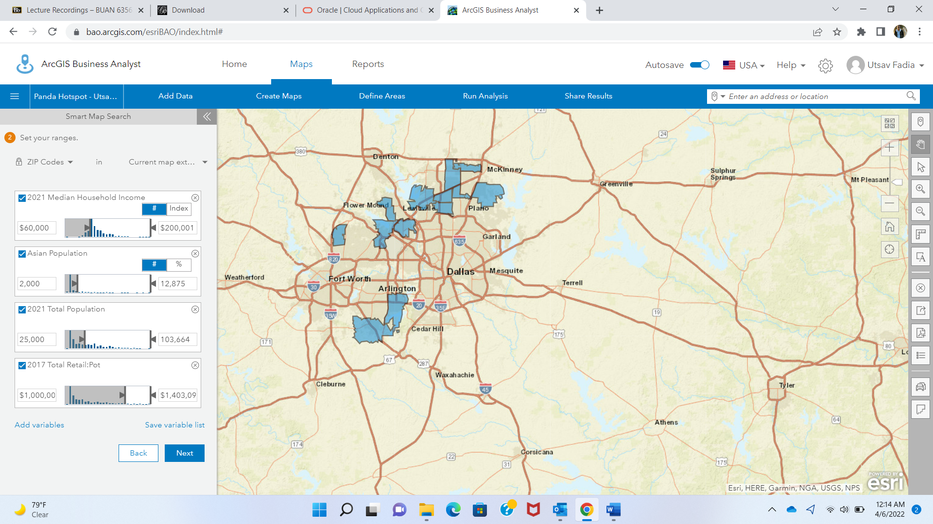

Q8)

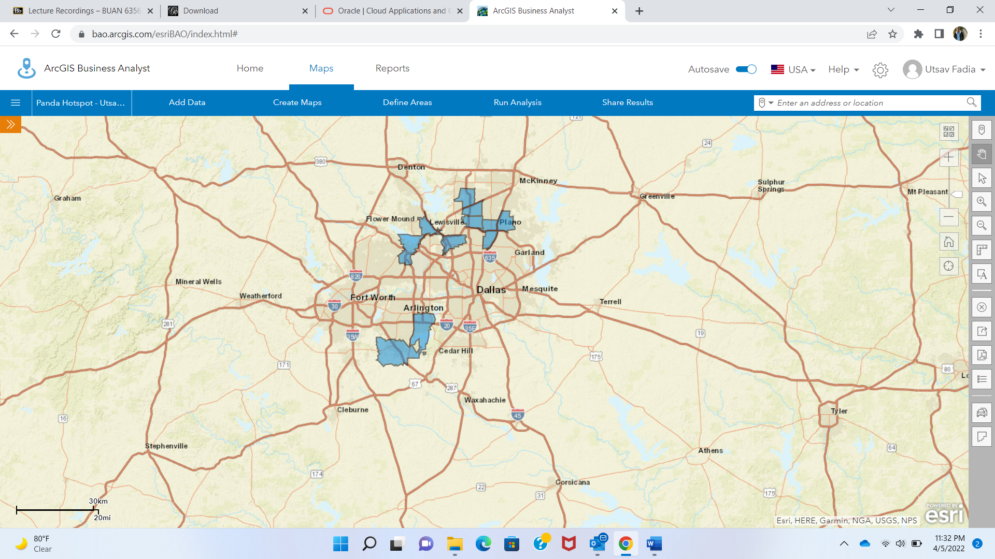

Q9) List the exact Tapestry you selected for the following:

Customer Profile 1: 2021 Boomburbs (1C) Tapestry Adult Population (Esri)

Customer Profile 2: 2021 Laptops and Lattes (3A) Tapestry Adult Population (Esri)

Customer Profile 3: 2021 Trendsetters (3C) Tapestry Adult Population (Esri)

Customer Profile 4: 2021 Up and Coming Families (7A) Tapestry Adult Population (Esri)

Customer Profile 5: 2021 Young and Restless (11B) Tapestry Adult Population (Esri)

Q10)

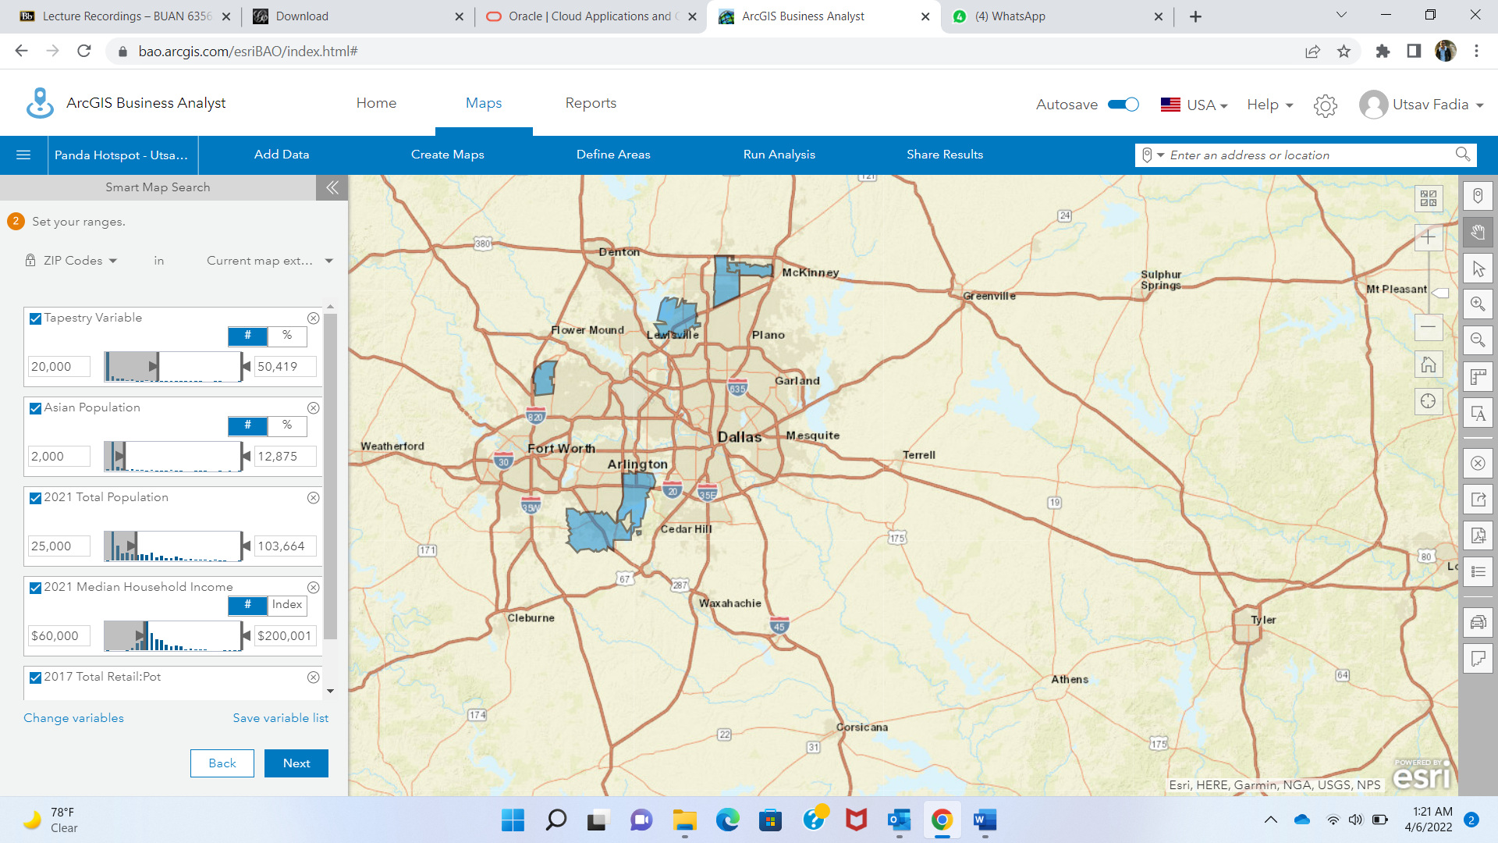

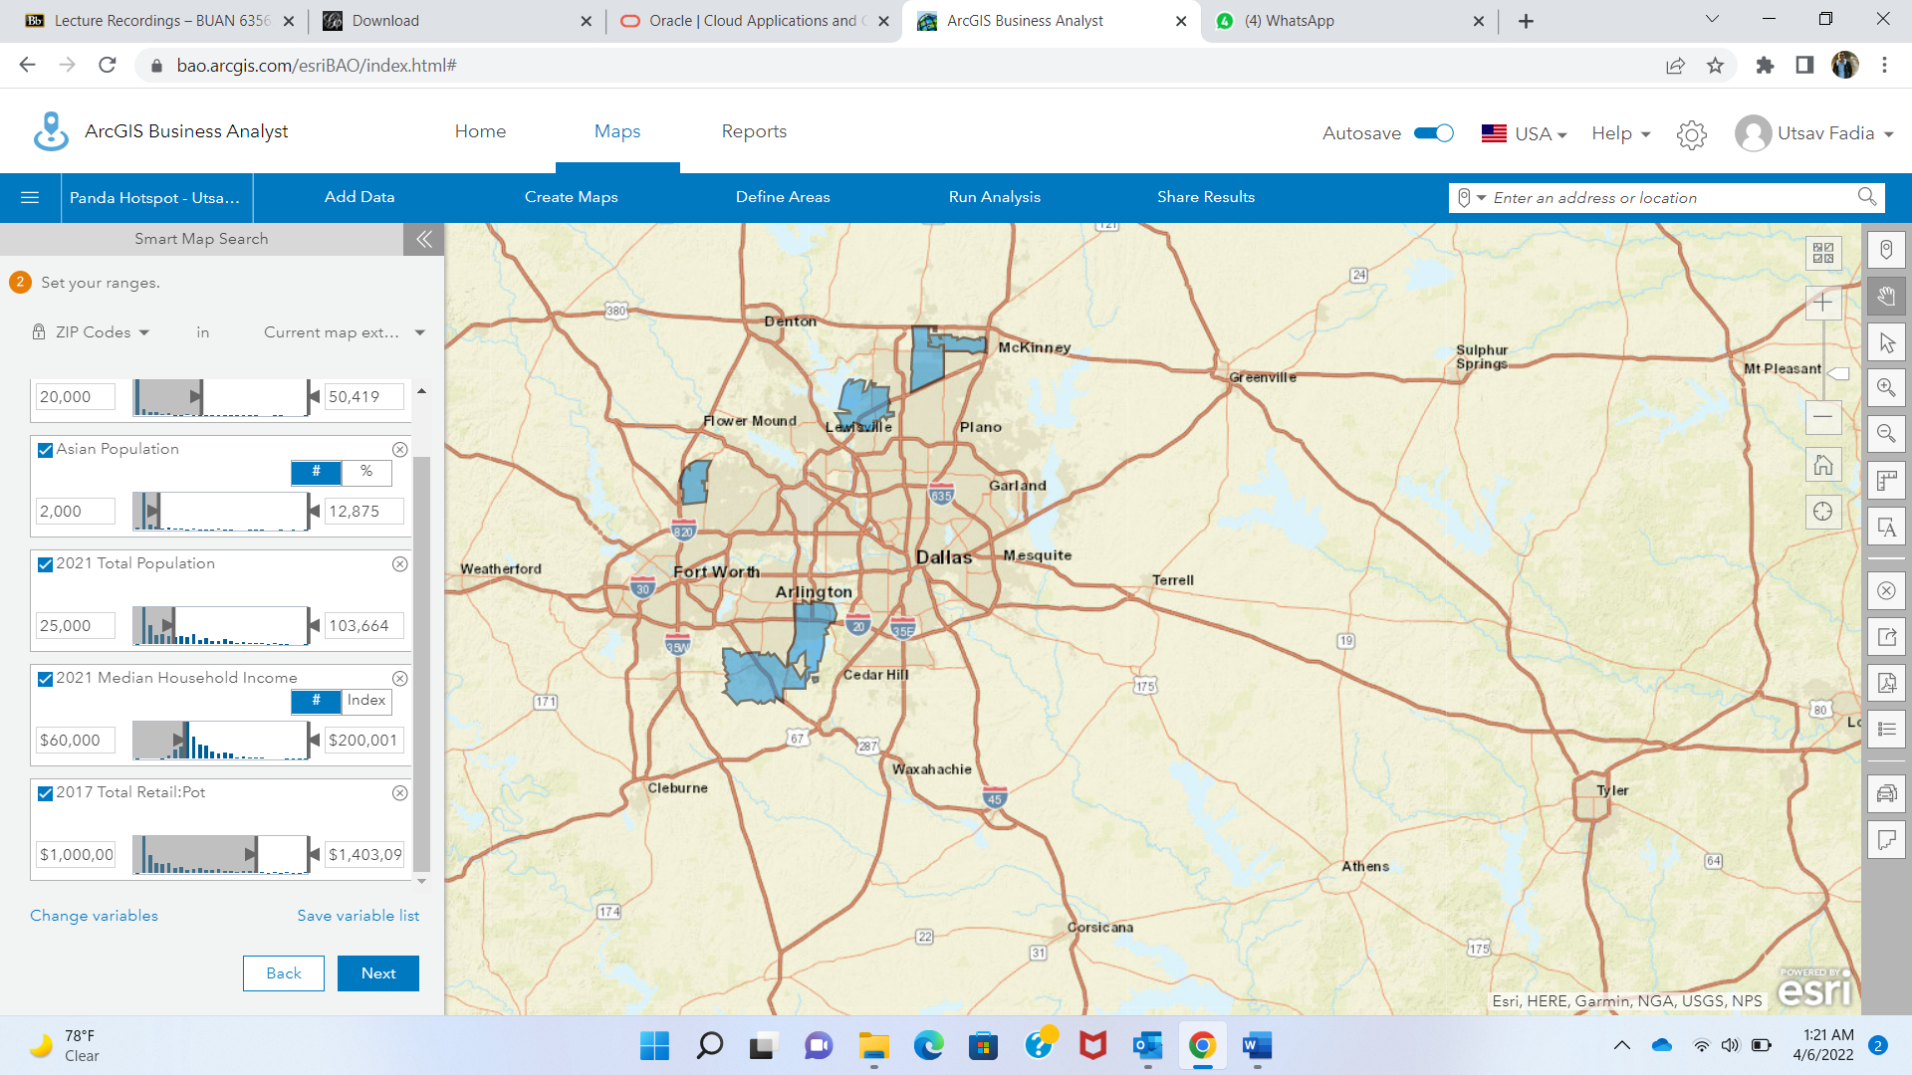

Q11)

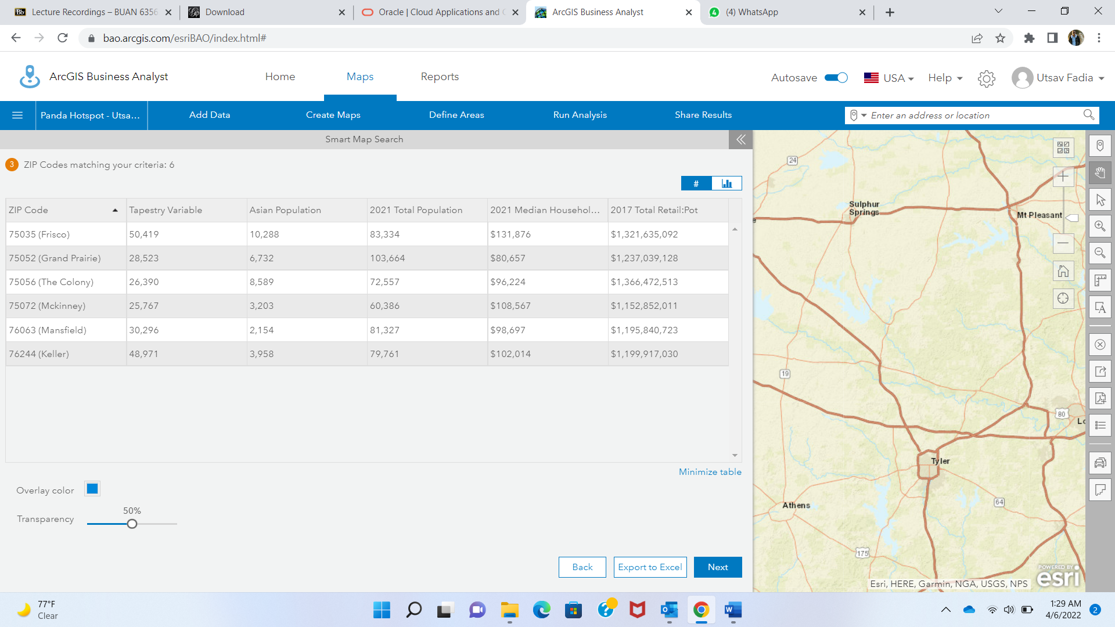

Q12)

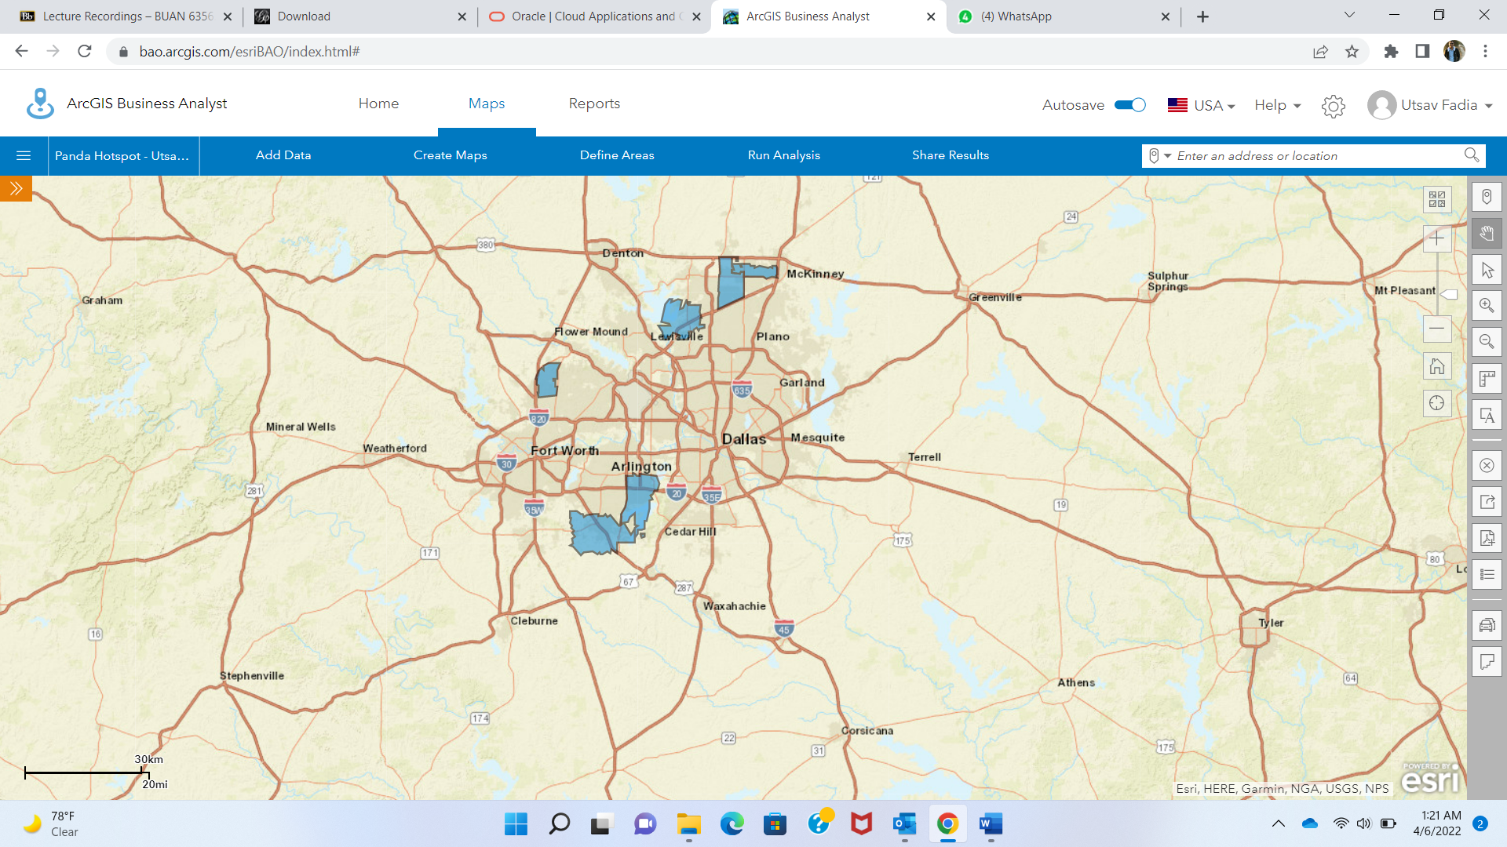

Q13)

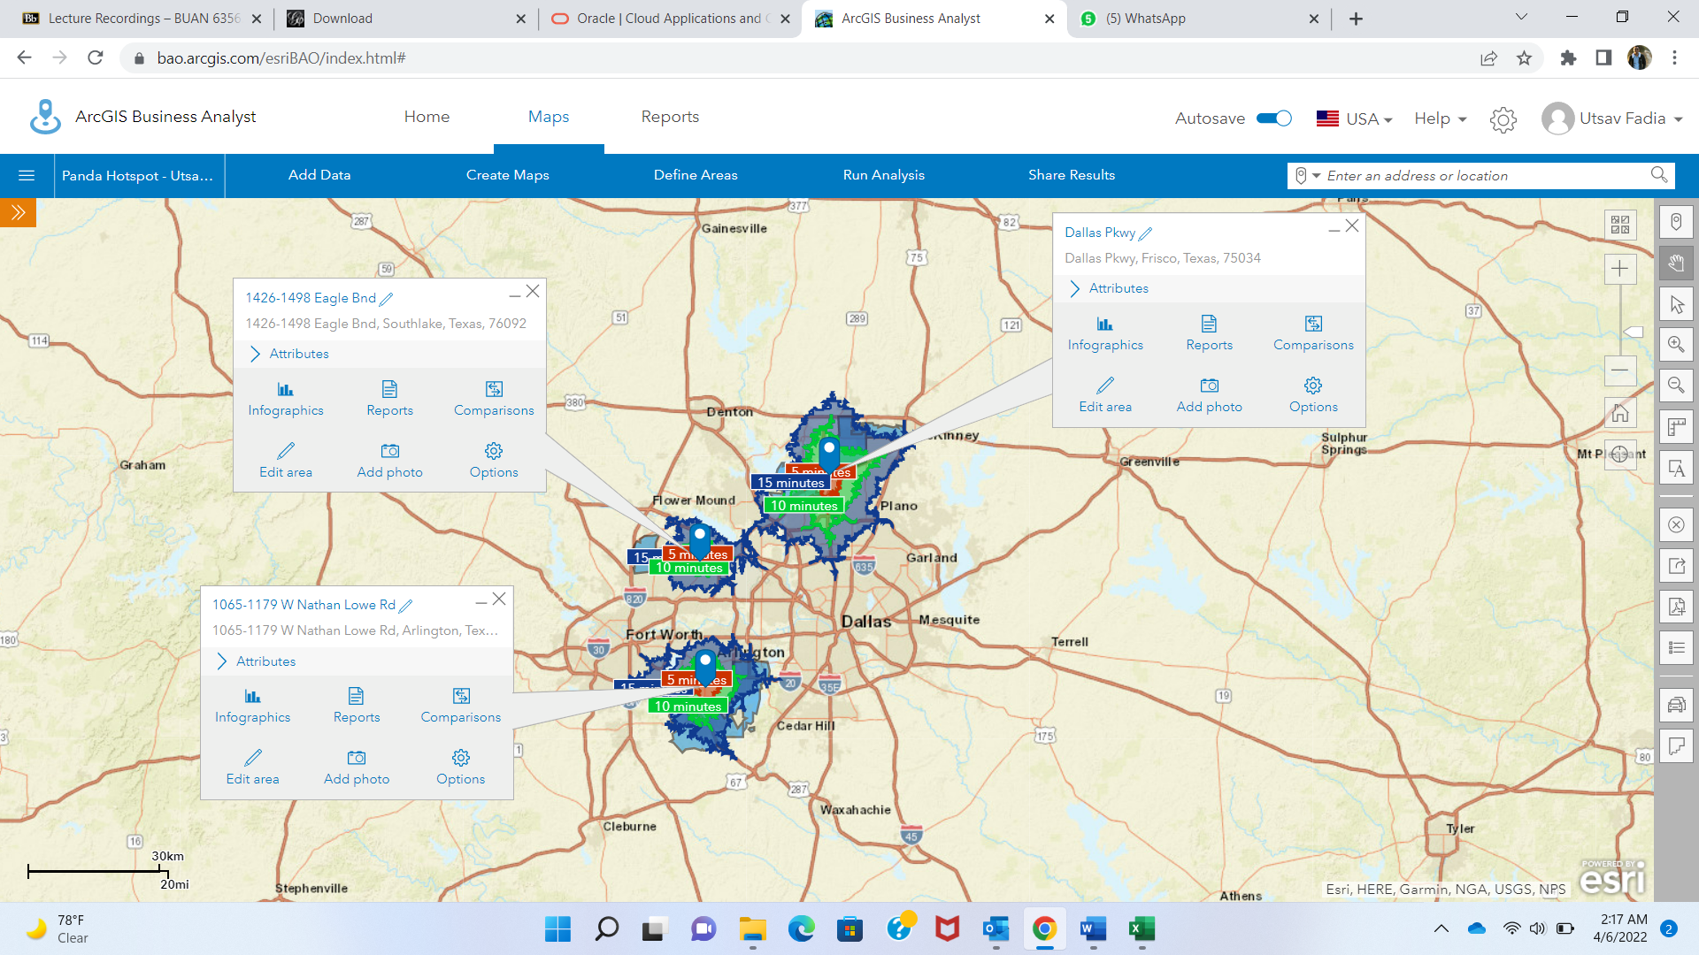

Q14)

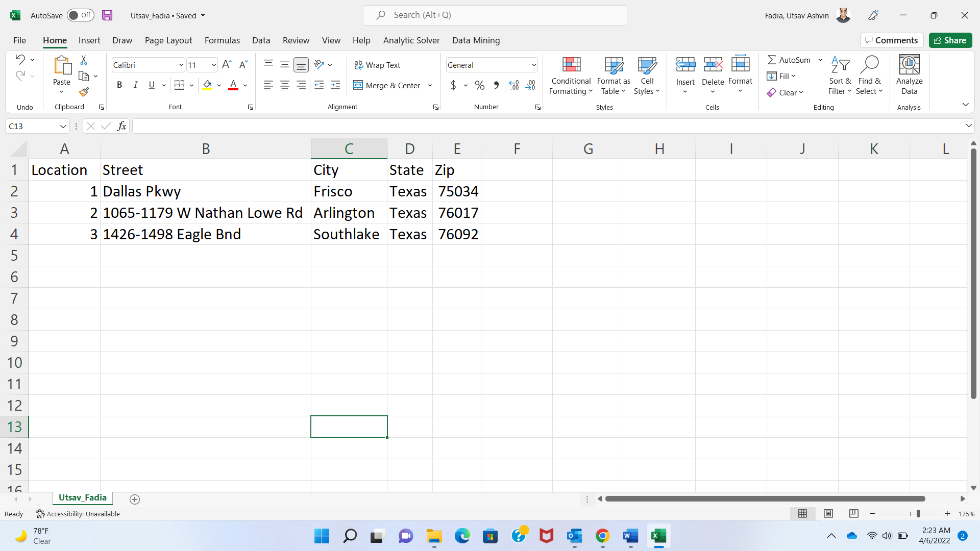

Q15)

Location 1

X = -96.823312 Y = 33.12459

Location 2

X = -97.144486 Y = 32.919853

Location 3

X = -97.131691 Y = 32.655427

Q16)

